
Introducing Equity Quality Assisted Learning (EQAL)
Table of Contents

THE EQAL PROCESS 2
EQAL Flow Chart 3
EQAL ‘HOW TO’ 4
USING EQAL 4
A TWO STEP PROCESS 6
PLEASE DON’T PUT IN YOUR END OF SEMESTER EXAMS 7
WHEN TO ADVISE 7
Mid (or Inter-semester) Semester Tests 7
INPUTTING ASSESSMENT DETAILS 7
WHERE TO GO 9
OTHER ASSESSMENT TIPS 10
Examinations 10
Deferring Exams 10
COURSEWORK SUPPORTS 11
ALTERNATIVE PRINT MATERIALS 13
University produced materials 14
For text books 14
Proof Of Purchase 14
KEY TIME LINES FOR SUPPORTS SUMMARY 16

THE EQAL PROCESS
- You contact the Equity Office to register. You will be interviewed by a Disability Officer (DO) who will identify and discuss your support and negotiate reasonable accommodations. You need to have supplied medical/specialist documentation in support of these accommodations.

- Electronic documents for specific supports are forwarded to key areas (i.e. library, parking, and alternative print) as required.

- With your permission your EQAL plan is forwarded to the Faculty Dean/Head of School and Academic Chair for your area of study especially to inform of coursework support.

- Equity places a ‘flag’ on your Callista record indicating that you have elected to disclose your EQAL plan. On downloaded class lists this flag is located at the very end of the spreadsheet where the scholarships/elite athlete flags are located. On individual records it is located across the top with DOM/INTL status.

- You use your EQAL plan with Unit Coordinators/Tutors where needed. Equity highly recommends that you advise your Unit Coordinators (and where appropriate your Tutors) that you are registered with Equity and have an EQAL plan in place. Please inform UC/Tutor either prior to or in the first couple of weeks of semester or soon after you obtain the EQAL Plan.
  - You and each Unit coordinators should be aware that whilst the study and/or assessment accommodations documented on EQAL are of a general nature, some specific action at Unit level may be required.

  - It is the responsibility of Unit Coordinators, in consultation with you, to identify possible additional needs regarding their Unit. Agreed accommodations and/or services can be implemented directly as long as they are consistent with the EQAL plan. Unit Coordinators are encouraged to liaise with the DO listed on the EQAL plan if there are issues that need further negotiation, or there is additional resourcing and/or information requirement.
    - Please note that each unit has its inherent academic requirement to be fulfilled by ALL students in order to pass the unit.
    - The EQAL Plan does not alter the inherent requirements. You may need to assess suitability of a course to your medical/disability background if you find the inherent requirements are difficult to meet on medical/disability grounds. Please involve your DO, Academic Chair and Dean in the process of assessing suitability.
  - If the Unit Coordinator and student are unable to find a mutually satisfactory arrangement, they need to notify the relevant Academic Chair. The Academic Chair may then convene a meeting to resolve the issue with the student, Unit Coordinator, Equity Office representative (which may be the student’s case manager (DO) or the Manager of Equity & Social Inclusion).

EQAL Flow Chart
1. You (the student) obtain supporting documentation
(Such as a medical certificate/treating specialist letter/assessment report)

2. You provide this information to Equity either before or at your initial interview with the Disability Officer (DO)

3. DO discusses your support needs with you

4. EQAL- your learning support plan is developed and finalised with the DO

5. EQAL Plan sent or supporting information used by DO to …

6A. School Dean and Academic Chair when coursework or formal assessment support is indicated. (Equity does not notify UCs/Tutors)
6B. Depending on your needs memos can be sent to Library/Parking/Equity offices if and when required

6D. Exams office: Based on the EQAL, plan supports are lodged on the FMP Alternative exams database when final exam support is needed
6C. Callista: If your EQAL, has been sent it is deemed to be ‘active’. Equity staff can then update the main student database, Callista, with an EQAL flag. This means that, when a Unit Coordinator downloads a class list they can see which students have an EQAL plan (but not the content of the Plan)

7. Your Responsibilities:
- To inform Equity Office if circumstances change (for example disability issues, extended or frequent absences, or enrolment status);
- To advise Equity Office if any service or study accommodations are not meeting needs appropriately and discuss any necessary changes;
- To email Unit Coordinator and tutors (where appropriate) at the commencement of each semester to inform them that they are registered with the Equity Office and have an active EQAL Plan. This also includes emailing the relevant placement officer or coordinator if undertaking field trips/practica or other placement off campus;
- To provide a copy of their EQAL Plan, if requested to do so, to their Unit Coordinators or Tutors in support of an accommodation.

EQAL ‘HOW TO’

EQAL functions like a passport. So you can think of it as a system of visas providing entry (access) around the University to different types of resources and supports.

Participation in using EQAL is a voluntary process – you are under no obligation to use this system… but Equity feels that it will help and reduce the amount of time you spend arranging supports etc. You are responsible for notifying your Equity case manager if your supports need to be changed.

USING EQAL
Located: https://eqal.murdoch.edu.au/pages/student.php

This is a secure site and password protected. You will need your student number and password to log on.
(Remember this is different from your LMS logon refer to Equity if you have forgotten).
Your Equity Case Manager will have emailed you the Student Portal information.

This is the EQAL access page:

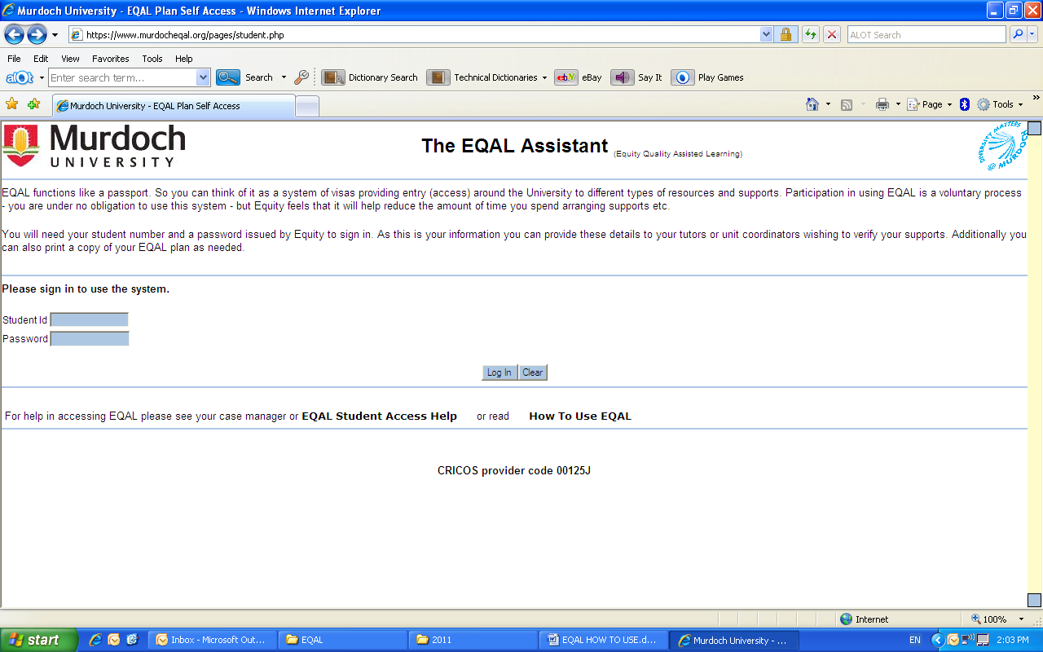

There are help buttons located on this ‘front page’ as well as in the system as well.

You may be prompted to redo your password when you log on for the first time or if Equity resend the student portal information to you. The choice of new password will be up to you.
EQAL PLAN

Your EQAL Plan can be accessed as a read only file.
As this is your information you can also provide your access details to your tutors or unit coordinators if they wish to verify your supports.

You can print of a copy of your EQAL plan or email it as needed.

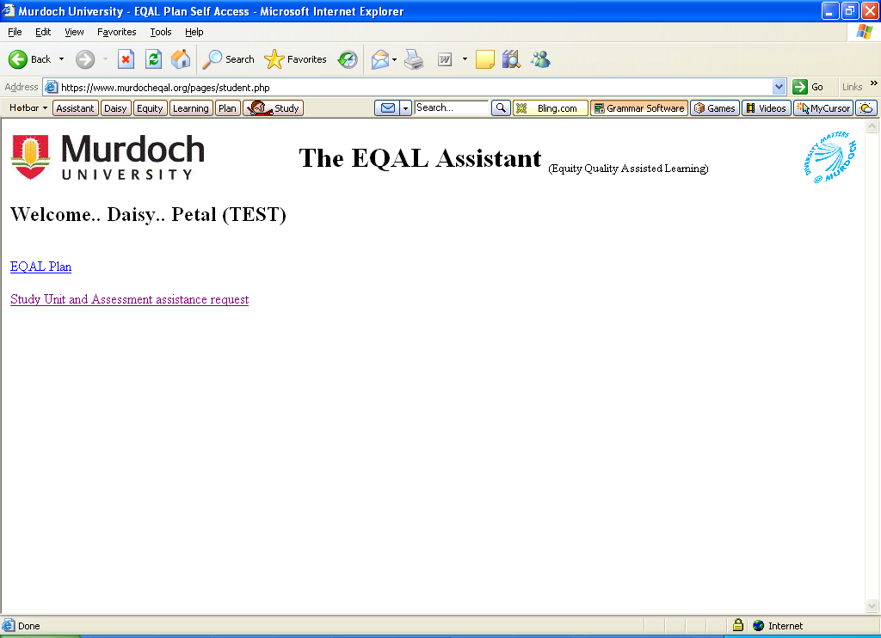

You can also upload your coursework and assessment support requests from this site instead of completing a form.
For students who are JAWS users there is also an HTML version available.

Please note that you will also see the following:

‘Note: When opening the EQAL Plan as a protected pdf document you may be
prompted for a password as exampled below. If so then click Cancel and then try a refresh of the page’

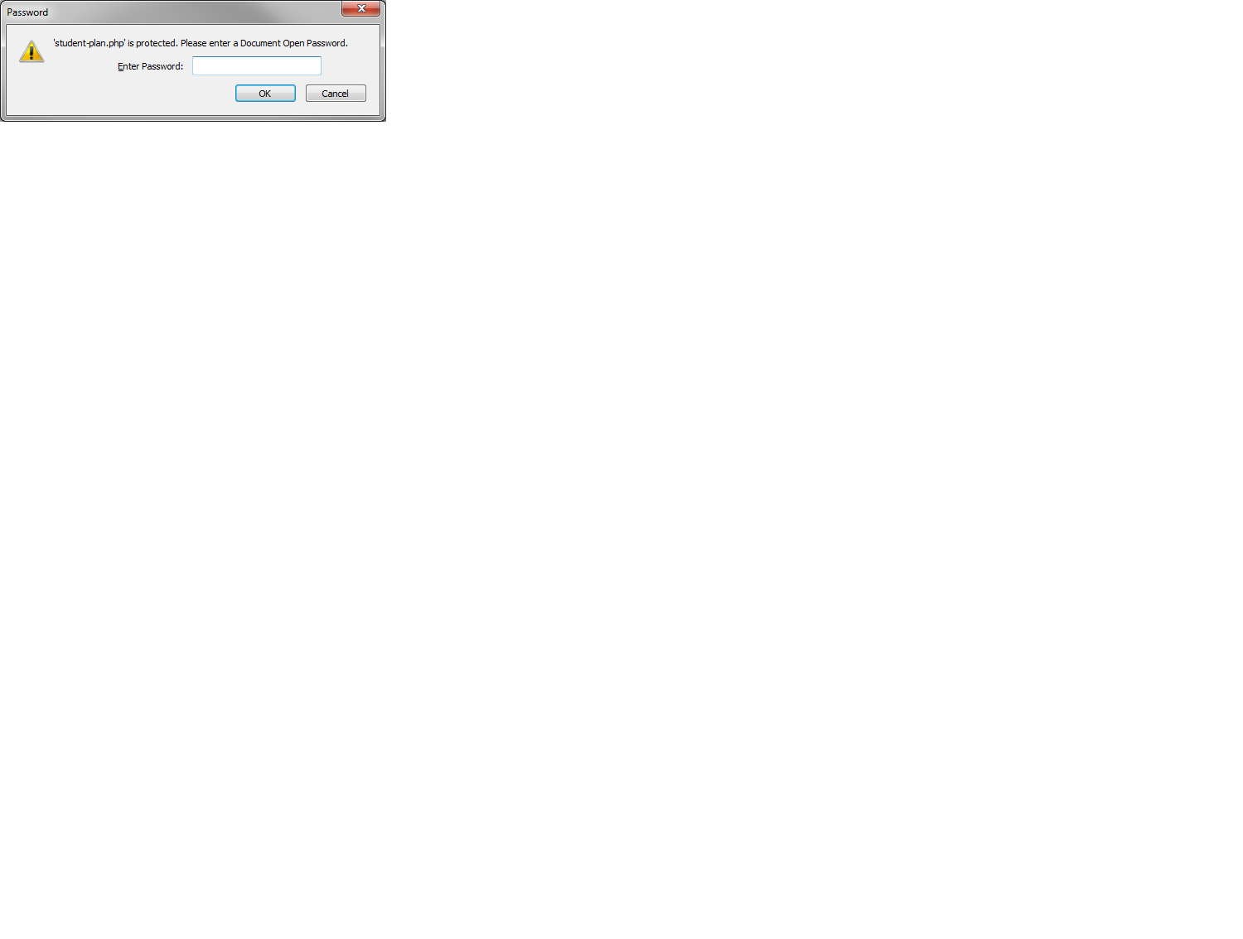

A TWO STEP PROCESS
For all supports you will need to enter the following four pieces of information:
From the drop down lists
1. Year
2. Semester details

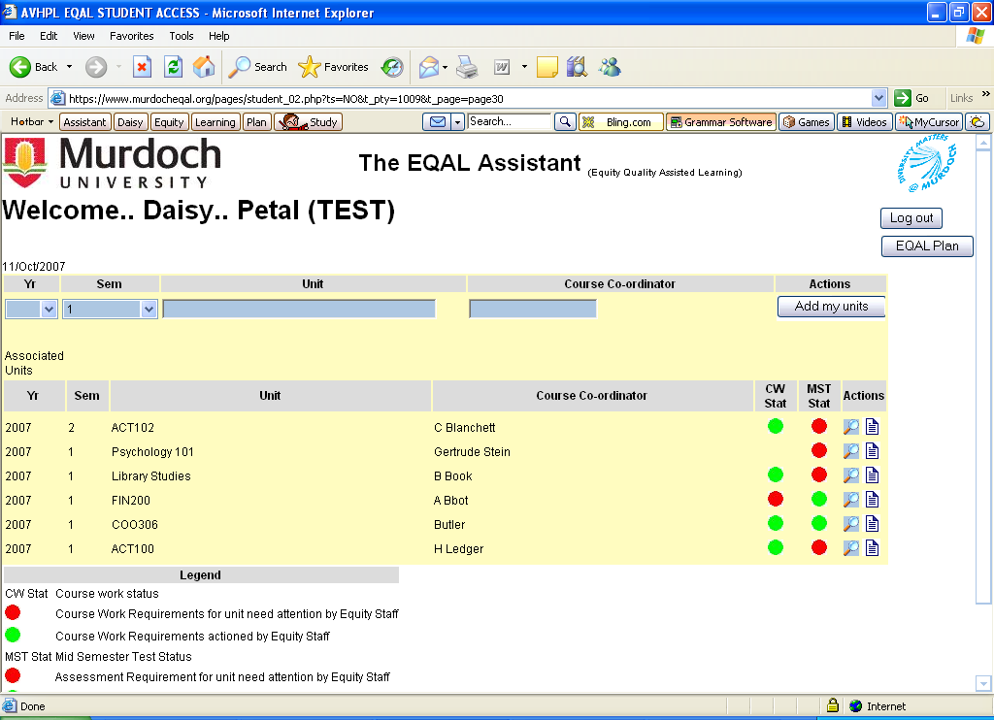
Followed by…
3. The Unit code ie ACT102 or PEC333
note this field only allows 6 characters to be entered for unit identification and
4. Unit Coordinator’s name
…then click the ‘Add my units’ button
The unit details will then be added into your record in date order. From this listing you can then choose to enter either assessment, coursework support or alternative print information by using the icons on the right hand side under the column titled ‘Actions’.

PLEASE DON’T PUT IN YOUR END OF SEMESTER EXAMS

Please advise Equity of your MST/In-class tests details that you want supports put in place for only – scheduled during teaching period.
For final examinations scheduled at the end of the standard teaching period (semester/trimester/Winter or Summer school) you will receive email from Exams office about support arrangements, date and venue. Equity supports roll over to each new teaching period. Best way to check is to look at the exams timetable to see if your unit(s) is listed. If it is there then you can assume that the Examinations Office will manage the process for you and this should be reflected in the email you receive from them.

Please advise Equity to receive supports for assessments that fall outside of Examinations Office’s responsibility (that is mid or inter semester tests) or exams where the unit coordinator has not arranged for their organisation through the Examinations office. So you will need to check with your unit coordinators to be sure that they are handling their unit’s assessment ‘in-house’. If this is the case then you need to let Equity know through EQAL database so that we can assist with the arrangements (like you would for a mid semester test).

WHEN TO ADVISE

Mid (or Inter-semester) Semester Tests
When you have Mid Semester Tests (MST’s) you need to input your information into EQAL as early in the semester as possible so that your assessment supports can be put in place.
It is really important for Equity to have sufficient time to organise your supports. We expect that you put your assessment details into EQAL so that we have at least three business/working days to make the arrangements – any later than this we cannot guarantee that assistance will be provided.

INPUTTING ASSESSMENT DETAILS

After uploading your unit details you can start by clicking on the icon. This will bring up a new page where you can add in the specific details about your assessments – you will need to let us know the date (DD/MM/YYYY), usual campus, start time and duration of the assessment.

If you don’t know the start time and/or duration details leave the information at the default settings.

Equity staff will email the Unit coordinator to confirm the information you have provided.

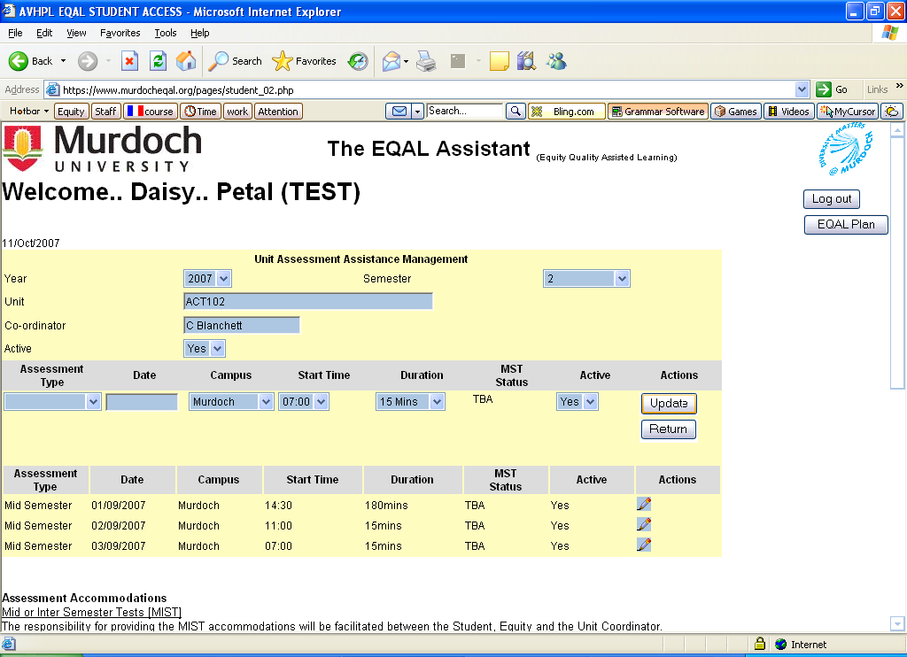

If you need to make changes to this information you can go back into the section and adjust where necessary until the ‘TBA’ status has been changed to ‘OK’ then you need to let your case manager know (Phone or email).

This page also lists the agreed supports for you – so let us know if you need to change anything as well. Once you have entered the details you can click ‘Update’ if you have further entries to make for this unit or ‘Return’ to go back to the summary page. If you log out before doing this the data will not be saved.

Equity staff will check EQAL regularly for new entries. Once we have made the necessary arrangements we will change the status to ‘OK’ – this will also change the button from red to green.

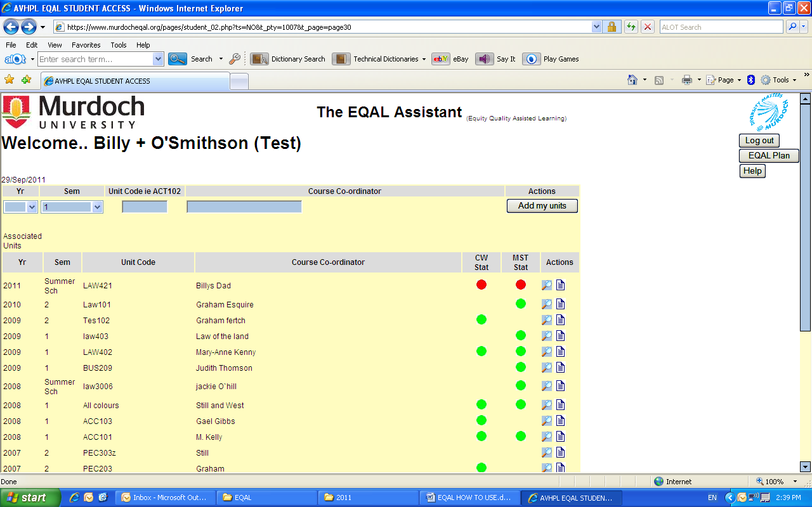

WHERE TO GO
You can also check EQAL to see if the location and supervisor have been added by following the steps after logging on.
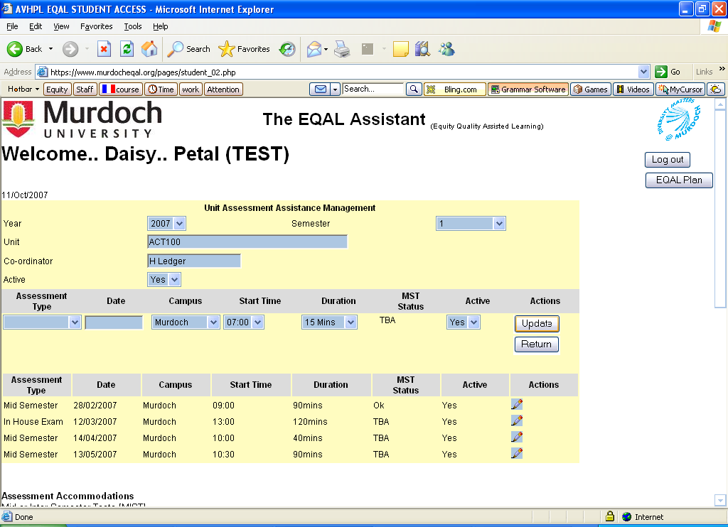
- Find the unit you are wanting to check and click icon .
- Find the date your are wanting to check and click icon (under Actions)
You will be able to log on to see where your assessment has been scheduled as well as any comments that staff may have made about this assessment.

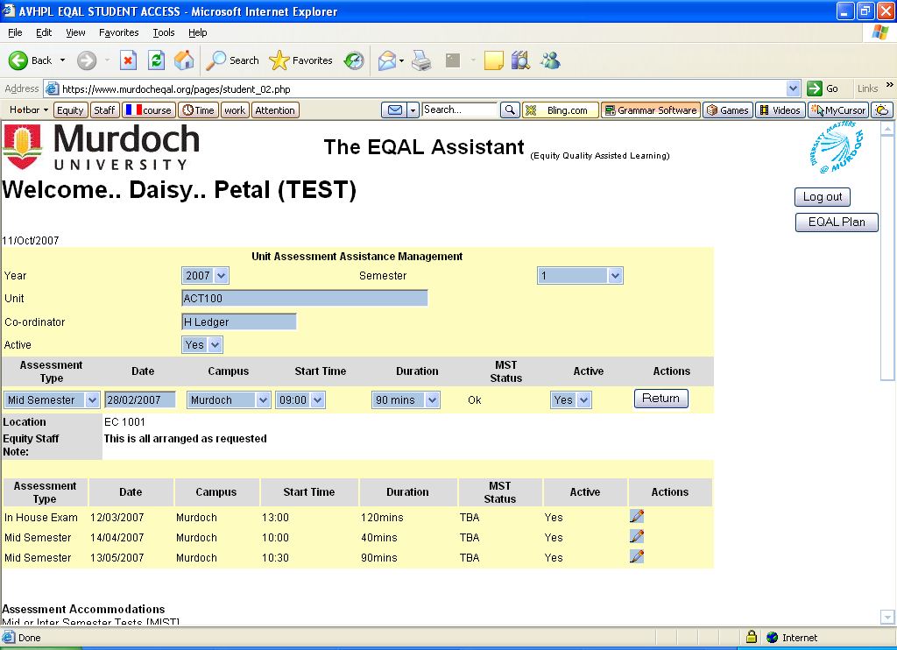
Don’t worry if there isn’t anything entered. Unless an Equity staff member contacts you to advise differently the alternative assessments for South Street campus will generally be scheduled near the Equity Office (ECL1.015). A good practice is to arrive at the Equity Office 5-10 minutes before your scheduled assessment time so that you can find out where you need to be.

OTHER ASSESSMENT TIPS

Examinations
If you had alternative arrangements last semester, these will transfer automatically continue across to the next semester.

Please let us know if your accommodations have changed from last semester so that we can upgrade the information that the Examinations Office is relying on.

Also if you have intermitted study for a semester or more your supports may have lapsed – best to contact your case manager to check and update your information.

Our Examinations Manager generally emails all students on the database by week 12 to confirm your supports are recorded and the venue/time for your assessment.
Remember to:
Check emails regularly (including your Junk/Spam mail folder if applicable) as the venue may need to be changed
Run off the email that has your supports listed
Know where you are going - campus floor plans can be checked by using the link: http://www.murdoch.edu.au/ofm/floorplans/floorplans.html

If you have not been contacted by week 14 and had set up alternative assessment arrangements then get in contact with your Equity staff member or the Exams Office as soon as possible.

Deferring Exams
Advise the Examinations Office (9360 2544) before the start of scheduled assessment, if possible. You have 3 working days from the date of your exam to apply for a deferred assessment.
Apply for the deferral using the application form and medical certificate
Hard copy – forms are available from outside the Equity office
Electronic web link: http://www.murdoch.edu.au/oss/exams/deferred.html <http://www.murdoch.edu.au/oss/exams/deferred.html>
Return the forms to Student Services Centre or fax through to 9360 7571.
Deferred & supplementary exam period is usually the week prior to the start of the next semester.

COURSEWORK SUPPORTS

Does your EQAL Plan include the provision of supports like peer notes or ergonomic equipment for your lectures or tutorials? You can advise Equity of your lecture and or tutorial details via EQAL as well.

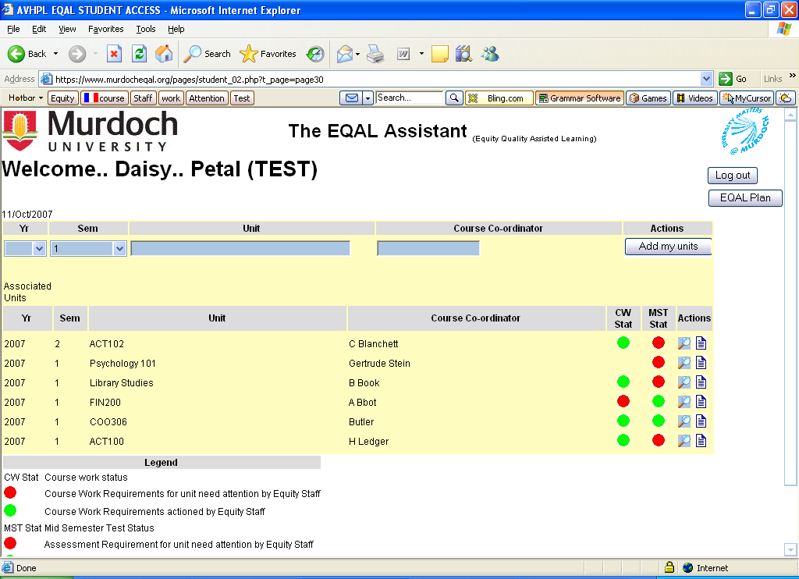
The requirements are the same as for the assessment section in that you need to enter the standard unit information then click the magnifying glass icon.

This will bring up a page for that particular unit which also lists your agreed supports.

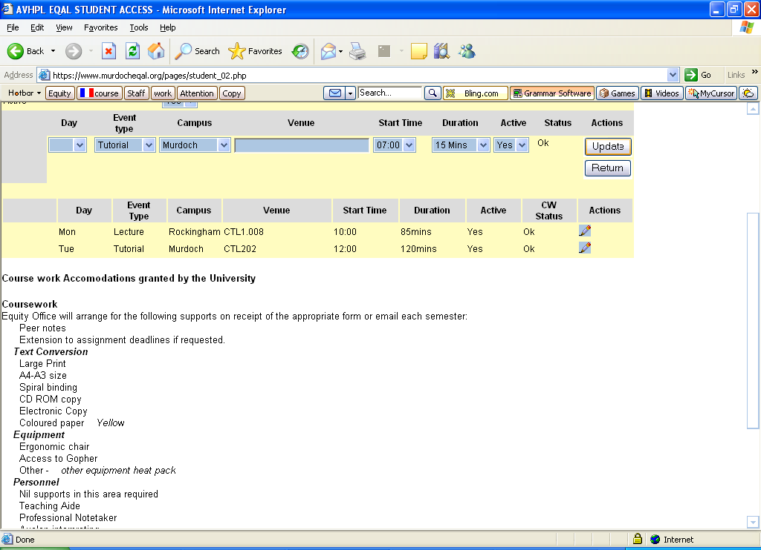
Enter in the data: Day, Event type and Campus from the three drop down lists.
You also need to enter the location (venue) of the class and duration.

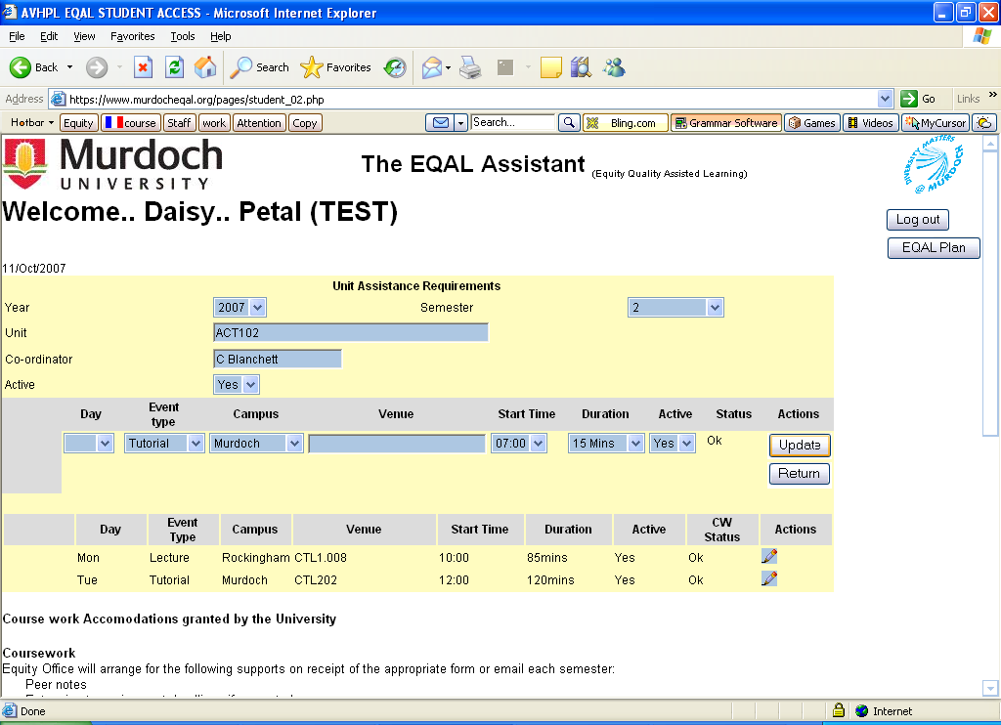

Click the update button to get the details uploaded onto your unit list

If you don’t need all the coursework supports then you can click the review icon and leave a message. Then click update to save this into the system.

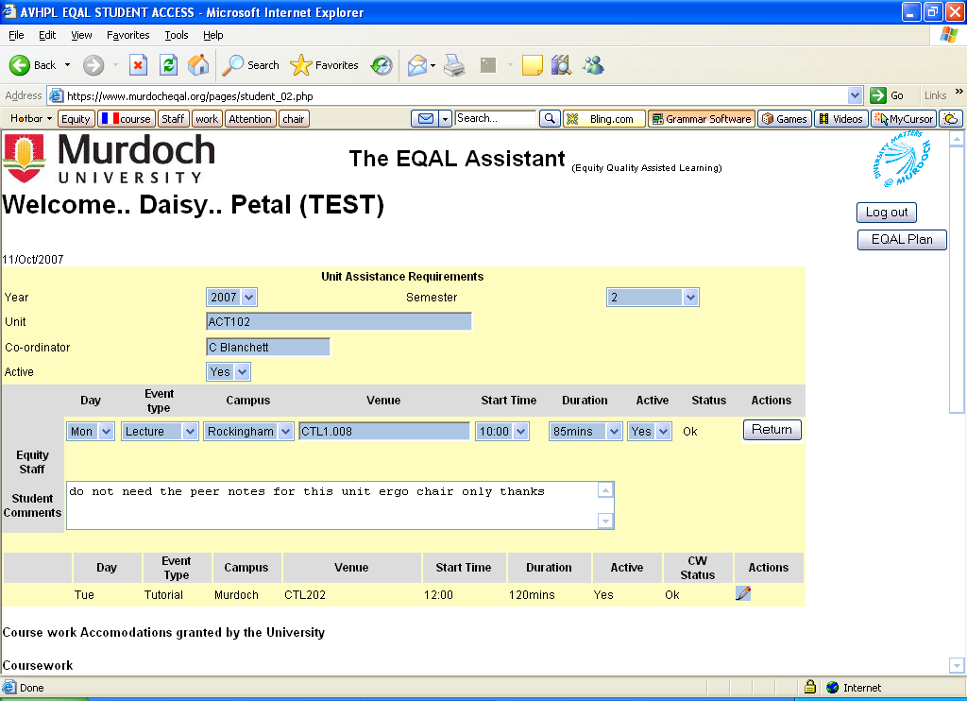

ALTERNATIVE PRINT MATERIALS

Please make sure that you enrol in a Unit first and then request Equity for alternative text. To ensure that you receive your materials in a timely manner it is essential that you advise Equity (through EQAL) of your requirement well before the semester commences.

To avoid delay (and not having your materials for the commencement of your unit(s) you need to get your requests in to Equity Administration as soon as possible before your unit commences. The following timelines are included here to assist you and serve as a general guideline.

In terms of materials to be converted there is some variation:
- For conversion to Word document then print, its 2-3 weeks (this is for Unit Readers mainly).
- Conversion into Word then into Daisy or screen-readable is 3 weeks.
- University copyrighted materials is 3 weeks (Unit Information Learning Guides, Unit Readers, Unit Lab Manuals, Unit Notes etc) This will cover all the options of hardcopy print to print, converted to Word doc print to print or standard PDF and converted print to Daisy or screen-readable versions
- For conversion from textbook to PDF or accessible PDF its 4-5 weeks.
- If you need a standard print conversion (this is for in-house unit materials on coloured paper, A4-A3 or alternative binding) the turnaround is less than 5 days.

The requirements are the same as for the assessment & coursework sections in that you need to enter the standard unit information if it isn’t already listed (Year, Semester, Unit Code & Course Coordinator then Add my units)

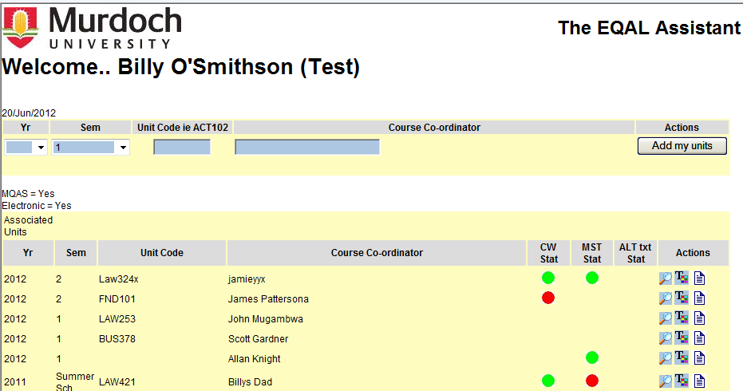

Then click the icon under the Actions section.

In the Alternate text format requirements area you need to indicate what items/material you are seeking to have converted by using the drop down box to read yes or no.

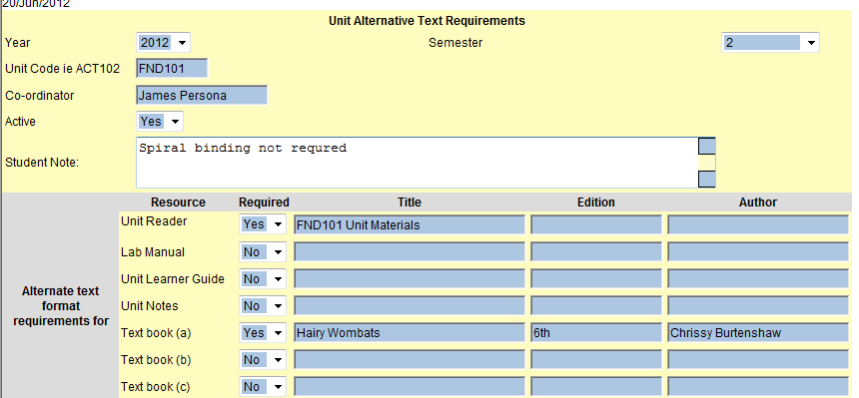
Then provide the information in the adjoining boxes:

University produced materials
(Unit readers, lab Manuals, Unit Guides, Unit Notes - materials produced by the University)

Enter the title of the material (you don’t need to supply edition or date).

Once Equity has your request we place an online order with Murdoch Print using our specific access format. This includes your contact number so Murdoch Print can call you when you unit material is ready for collection.
You then go to Murdoch Print (Library level... South Street) in person, pay the standard price for the materials, as you would in the bookshop, and receive your alternative print materials.

Equity will pay for the cost of conversion such as coloured paper, binding, A3 size, copies placed on cd etc. You will not be out of pocket any more than any other student.

For text books
Need to knows are: Textbook name, Edition and Author.

Proof Of Purchase
You will need to provide proof of purchase to Equity – this is for copyright reasons. Our Equity Administrator needs to physically see the invoice receipt from Bookshop or the online provider in the case of textbooks. We need to keep a copy – original or photocopied of this invoice for our own records. You can either bring this invoice into us or scan and email, but the scan has to be very clear, not smudged or blacked out. Equity will not commence conversion of text book materials until this has been received.
Additionally, if you need to have your text books spiral bound or A4-A3 printing then you will need to bring the original material into Equity to arrange for the conversion.

You can add your comments into the ‘Student Note’ section

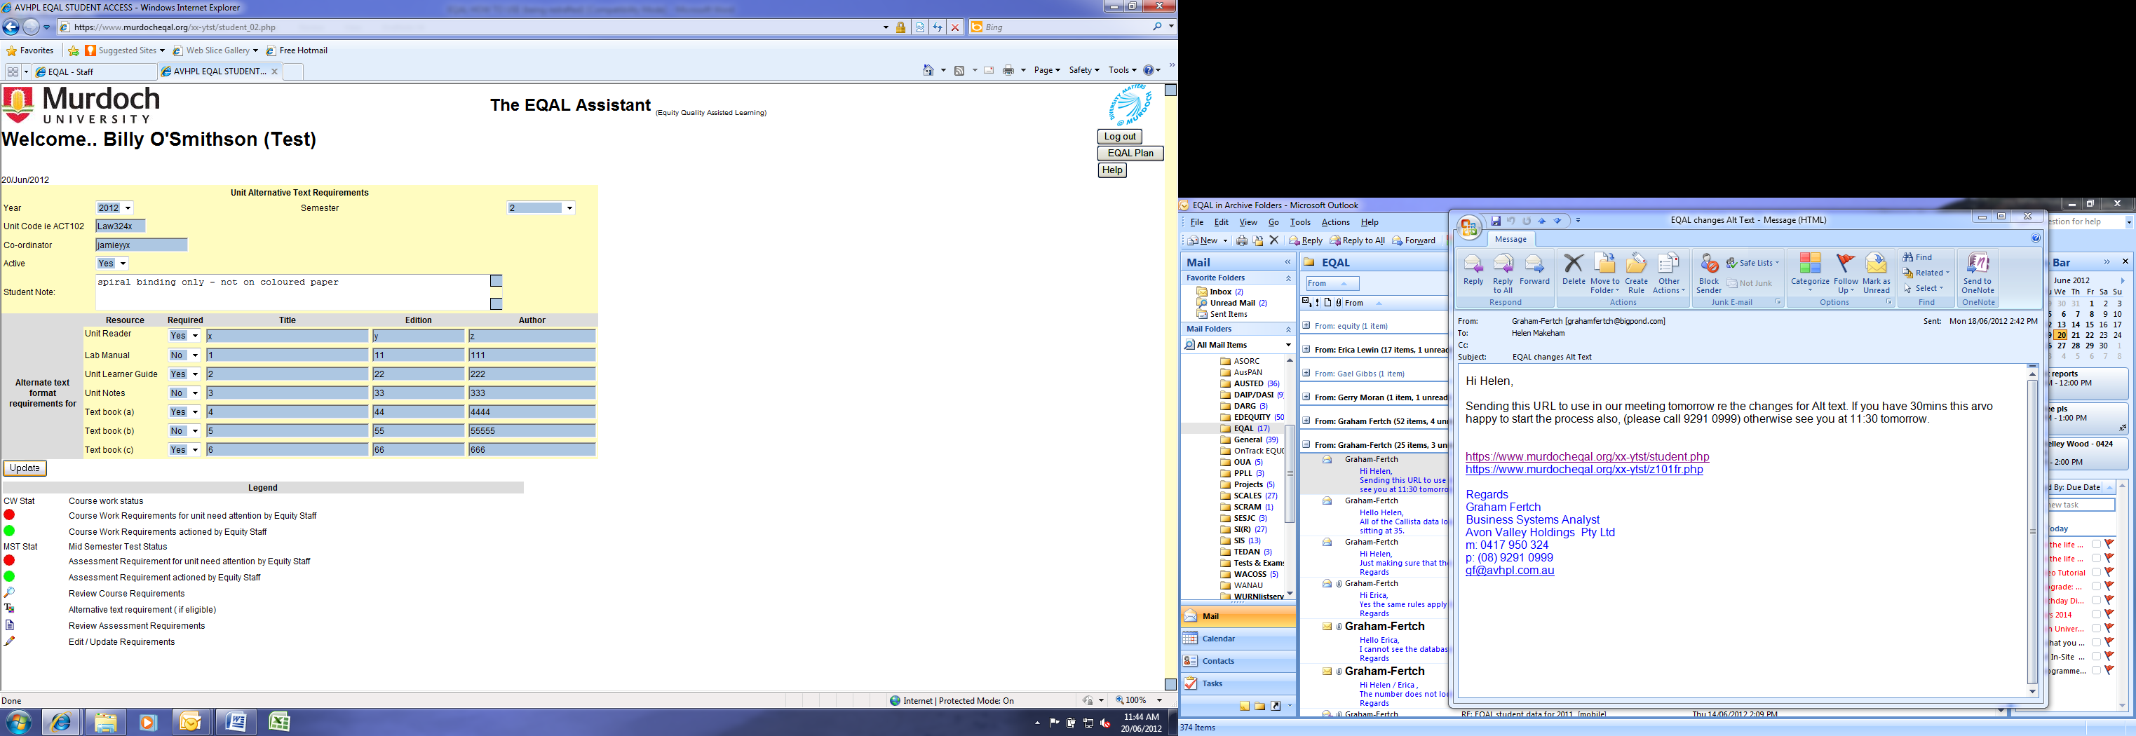

Then click the ‘Update button’ to save all the entries

You can make changes to your records at any time until the Equity Administration staff action the request. You will then receive this message: 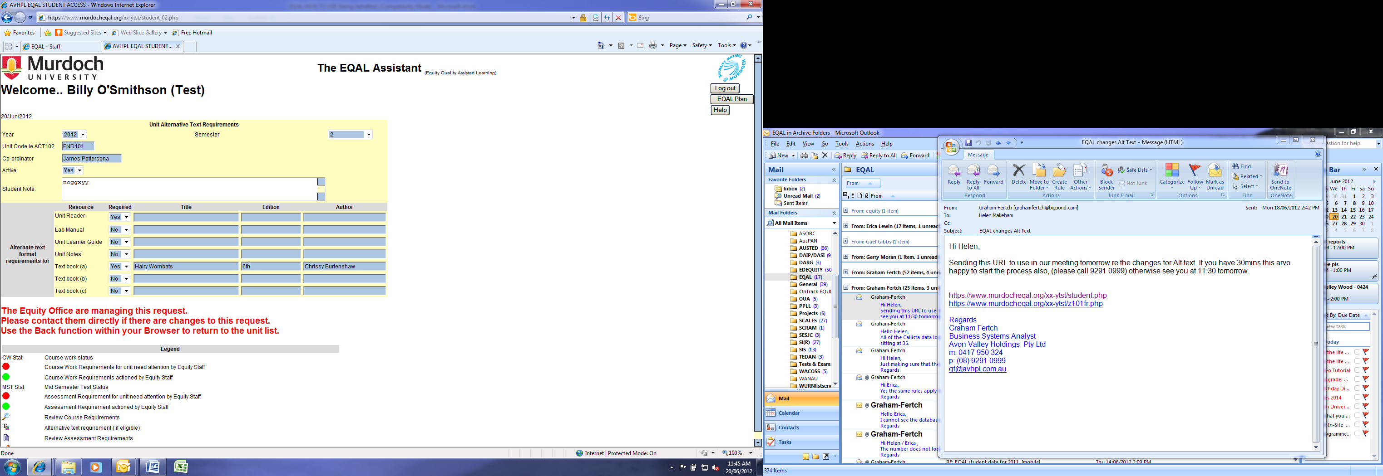

This means you need to contact the Equity Office to advise of changes
Email: equity@murdoch.edu.au
Phone: 08 9360 6084
KEY TIME LINES FOR SUPPORTS SUMMARY
Assignment Extension Provision
You are expected to advise their Unit Coordinators in a timely way.
Should you require an extension then, for each assignment, you need to:
Email or phone the relevant academic (Unit coordinator or tutor) before the due date of the assignment.
Advise the academic of their accommodation (extension without medical certificate) provision on the EQAL plan if this has not already been done.
Provide a copy of the EQAL plan either at the point of request or send in with the assignment (as you would with an extension/late assignment slip)

Mid Semester Tests & In-House Examinations (more info next page)
You need to enter the details for formal assessments on EQAL at least 3 full working days before the scheduled assessment.
Any requests submitted within 3 working days cannot be guaranteed.
Should Equity decline the request on the basis of late notification then you will need to, liaise with their Unit Coordinator to make other suitable arrangements.

Peer Notes & Ergonomic Equipment
Request for these supports need to be entered into EQAL and include all details regarding times and locations
In the case of new students at the beginning of the semester
For continuing students by the end of week 2 of semester.

Alternative Course Work Assessment
You are expected to advise your Unit Coordinator. Both you and your coordinator can discuss the needs and negotiate a suitable alternative.
Alternatively you or your Unit Coordinators can liaise with your case manager the Disability Support or Liaison Officer to clarify and support alternative strategies.

Alternative Print Materials
Request for these supports need to be entered into EQAL and include all details regarding the text material to be converted.
The turnaround time will depend on the type conversion being requested.
For textbooks you need to provide proof of purchase.

